URS Kaggle Tip dataset analysis and ANN model development
Source: https://www.kaggle.com/datasets/varishabatool/tip-prediction-dataset
Varibale overview:
- sex : gender (male or female)
- smoker : (Yes, No)
- Day : Thursday, Friday, Saturday, and Sunday
- Mealtime : (dinner or lunch)
- size : The number of guests at the dinner party

- Dataset overview and summary:
Variable | Type | Description
total_bill | Numerical | Restaurant bill amount in dollars ($3.07 - $50.81)
tip | Numerical | Tip amount in dollars ($1.00 - $10.00) - TARGET VARIABLE
sex | Categorical | Gender of bill payer (Female, Male)
smoker | Categorical | Whether party included smokers (No, Yes)
day | Categorical | Day of week (Thur, Fri, Sat, Sun)
time | Categorical | Time of day (Lunch, Dinner)
size | Numerical | Number of people in party (1-6)

Total Transactions: 244
• Average Tip: $3.00
• Average Bill: $19.79
• Average Tip Percentage: 16.08%
• Total Tip Revenue: $731.58
• No Missing Values: Dataset is clean and ready for analysis
- Exploratory data analysis:
  - Relationship between total bill and tip
By plotting total bills and tips on a scatter plot, there is a positive correlation with the R^2 = 0.4566, showing a mediate positive linear relationship between these two variables. The goal for this step is to have a general idea on the relationship between these two variables. The relationship is clear: guests tend to leave higher tips when the total cost of their meal is higher. The data points cluster well along an upward sloping line, supporting the use of a simple linear model to predict tips based on the bill.
On the right plot, it is used to investigate your hypothesis: “the increasing number of party size, the increasing number of tips it will be.” This hypothesis is generally supported by the graph. However, group size of 5 or 6 showing a higher variability than smaller group size.
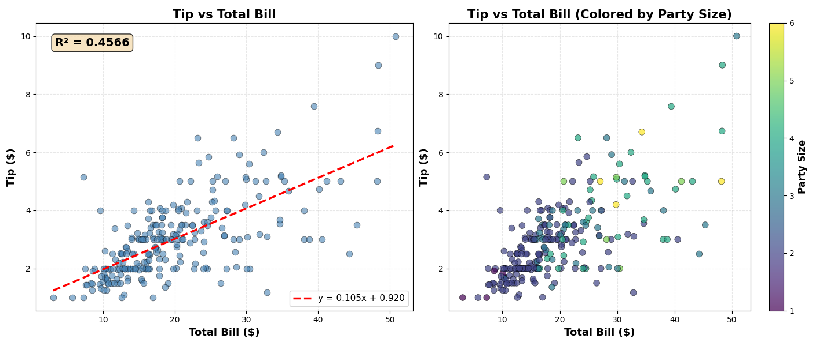

  - Tip distribution by sex:
Violin plots reveal the distribution of tips between male and female customers. Both groups show similar tipping patterns with comparable median values, except for male shows a longer tail.
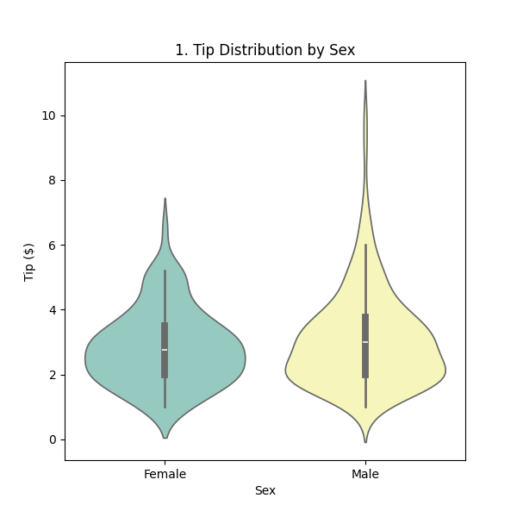
  - Tip distribution by smoker status
Comparison of tipping behavior between smoking and non-smoking parties shows minimal differences in tip distributions
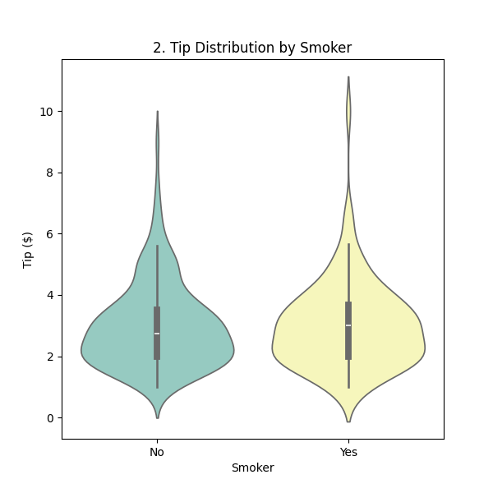
  - Tip distribution by day of the week
Saturday demonstrates the highest range of tip and Sunday generate the highest tip media.
